HILOTHERM Homecare Operating Instructions
HILOTHERM Homecare Type HTP1
Before putting the Hilotherapy system into operation, carefully read the operating instructions. Pay special attention to the instructions labelled Caution and Warning.

See information & downloads on hilotherapy.nz for full operating instructions.
1. General Description
1.1 Intended
The therapy device Hilotherm Homecare HTP1 is used for treating, alleviating and compensating localised injuries, diseases and their after-effects by means of a mild and constant cold. The cold is transferred through the skin by placing cuffs on the area of the body to be treated (e.g. a face cuff below for cooling after jaw surgery).
The benefit of the device is always achaived when a cooling effect is applied to the area of the body to be treated through the cuff, reagardless of how large the temperature difference is between the cuff and body surface.
The temperature can be individually adjusted from + 15 °C to + 22 °C. The device is designed for continuous operation.
The Hilotherapy system is not suitable for reducing (hypothermia) or raising a patient's core body temperature.
1.2 Fields of Application
The Hilotherapy system may be used in various medical areas in the acute phase as well as the remodelling phase, and can effectively help chronically ill patients (e.g. with rheumatism, arthrosis, migraine).
Fields of application
Surgery: Microsurgery, plastic surgery, vascular surgery, orthopaedics, trauma surgery, oral and maxillofacial surgery, oral surgery, oral implant surgery, ENT medicine, dermatologic surgery etc.
Sports medicine / Functional rehabilitation / Physiotherapy: Mobility improvement, pain reduction, muscle relaxation, distortions, muscle strains, muscle tears, sprains, tendon inflammations, bruises, oedemas
Rheumatology: Inflammatory rheumatism, Algodystrophic syndrome, Ischialgia
Other: Dermatology (laser treatment, liposuction, wrinkle injection, photodynamic therapy), emergency medicine, fever, migraine and tension headache
Recommended temperature settings
A successful therapy can be achieved at a temperature setting of 15 °C to 22 °C.
1
Recommendation
The therapy should be started with a setting of 18°C. The temperature setting can be raised or lowered depending on the sensitivity of the user (too cold or too hot). It is important to have consistently uniform cooling. The temperature of the sleeve should feel pleasantly cool.
Duration of application
The therapy should be continued for as long as the swelling or pain persists.
1.3 Indications and Contraindications
Indications for Hilotherapy
The indications for the use of hilotherapeutic measures are based on the ideas of the physiological mode of action of cold applications. The cold-induced adaptation processes, which occur on several levels in an interlinked manner, can be assigned to two principles of action: Depending on the temperature of the cold medium and the application time, more initial effects are being relayed with regard to vasomotion, pain and ⟨alpha-gamma-motor neuron activity. A longer period of temperature decrease exposes subjacent structures and layers of tissue to the direct cold effect. Thus, the re-warming period varies accordingly.
Important factors in the intensity of the local and systematic effects of a cold stimulus are - besides the temperature and duration of the application - the physical properties of the cold medium, the initial skin temperature and its thermal conductivity as well as the area of the body and the size of the application area. The significance of this distinction lies in the necessity to clearly differentiate between the various forms of cold applications and levels of cooling and to apply them according to the findings and in a purpose-oriented manner.
For disease patterns with an emphasis on analgesic and muscle tone reducing therapy, the hilotherapeutical procedures are essential elements in pre-treatment or interval treatment.
Contraindications of Hilotherapy
Regarding contraindications, we also have to differentiate between „cold“ and „ice-cold“.
With consideration to the primary disease, the contraindications are put into perspective according to the levels of cold. Some diseases, for which the application of ice or comparable media is contraindicated, can be effectively treated with somewhat milder forms of cold. All forms of cold applications are considered to be contraindicated for the emergence of cryoglobulin anaemia, cold haemagglutination and cold urticaria /cold contact urticaria caused by histamine release. Also contraindicated for Hilotherapy are diseases from the range of functional circulatory disorders (e.g. M. Raynaud), severe arterial obstructions, pronounced sensibility disorders and trophic tissue lesions. Provided adequate precautions are taken, mild cold stimuli can be applied for arterial circulatory disorders, mild forms of sensibility disorders and for patients with angina pectoris.
Caution: In patients with compartment syndrome, it is absolutely required to make sure the cuffs are applied without compression to avoid accelerating the already existing pressure increase and the accompanying perfusion disorder.
1.4 Requirements for Operator
Operation of the Hilotherapy system is simple and can be carried out by nursing staff or by the patients themselves. However, the application should be supervised by qualified medical personnel.
The operators shall familiarise themselves with the operating instructions and the device before initial operation. The application of the cuff in particular must be carried out with care.
2
1.5 Machine Description
The Hilotherapy system HTP1 is a mobile device for localised, professional cold treatment. It distinguishes itself by its simple handling and ease of operation.
The temperature setting is adjustable from + 15 °C to + 22 °C.
Sensors record the actual temperature in the cooling system. The time it takes to reach the target temperature depends on the ambient temperature and the size of the cooling cuffs attached. It may be that the set temperature is not reached with ambient temperatures above 25°C or large cuffs. The accuracy of the temperature control is +- 1°C.
Basically, the Hilotherapy system consists of the following components:
Liquid Air Modul: The Liquid Air Modul serves to precisely control and maintain the temperature of the distilled water according to the chosen values.
Control unit: Through the device’s sensors, the control unit acquires the current data and records them. It also controls the machine’s processes. The desired temperature values are entered via the keys (pos. 04).
Display: The display (pos. 03) shows the set values and the current operating condition.
Cuffs: The cuffs transfer the cold / heat to those body regions to be treated by pumping distilled water at a certain temperature through the cuffs.
01 Couplings
02 Fillling hopper
03 Display
04 Keypad
05 Venting slots
06 Carrying handle

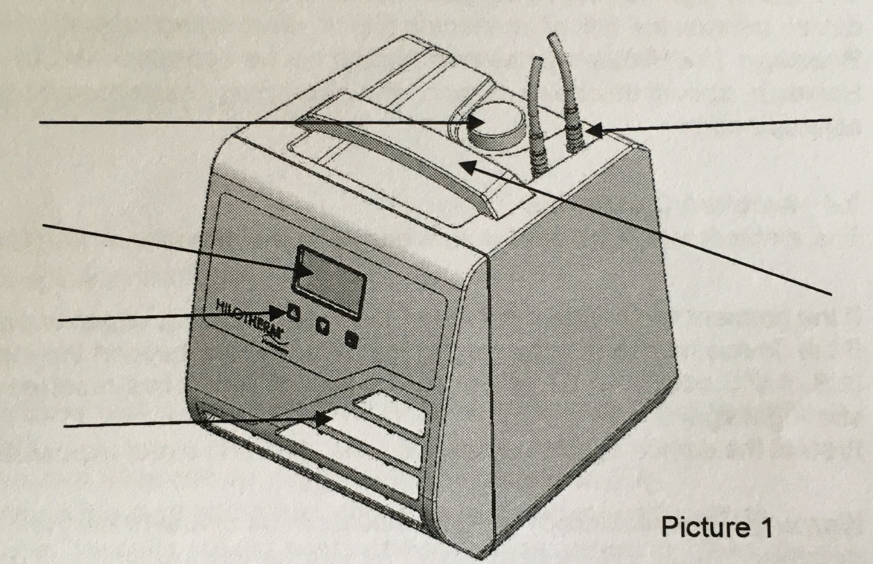
2. Safety Instructions
2.1 General Safety Instructions
- Before machine startup, the operator has to check if the device and the application parts are in a proper state.
- The therapeutical system always consists of a Hilotherapy device, duo hose and cuff(s).
- Use and connect only the original Hilotherapy devices and cuffs.
- The cuff must be removed if it cannot be used as intended because of fault.
- During treatment, especially when using several or large cuffs, the patient’s body temperature should be monitored.
- The Hilotherapy system must not be used within an incubator.
- The cuffs may be damaged by sharp objects.
- The proper flow through the cuff channels may be obstructed by folding or compressing the cuffs.
- The flow through the tubing may be obstructed by kinks.
3
- Only fill up the tank with demineralised water.
- When filling up the tank with demineralised water, disconnect the device from the mains.
- Do not block or cover the venting slots on the front and rear panels.
- The device may only be operated when positioned on a level and flat surface.
- The device may only be used when all units and displays are working properly.
- In case of failures, switch the device off immediately. Only after the failure condition was rectified, the machine may be used again. Please inform the manufacturer of any kind of critical or unclear errors.
- Warning! It is not permitted to modify the device.
2.2 Hazard Instructions
- Do not open the housing.
- Prior to maintenance, disconnect the device from power supply.
- Machine maintenance may only be carried out by a qualified service technician.
- The AC voltage source must comply with the data given on the type plate attached to the back of the machine.
- To ensure fire protection, make sure when replacing the fuses that only the same type of fuses with the same nominal values are used (refer to type plate).
2.3 Electromagnetic Compatibility
In electrical medical appliances, particular attention is to be given to the electromagnetic compatibility (EMC), that is the device is to be installed and commissioned according to the EMC- directions contained in this operation instructions (please see instruction and manufacturer’s declaration in the annex).
Portable and mobile radio communication devices may interfere with the operation of medical appliances.
The use of high-frequency surgical instruments or endocardial catheters with an active medical device creates the risk of an electric shock, electromagnetic interference or a fire hazard.
Warning: The Hilotherapy system should not be operated next to / on top of other appliances. However, should this be necessary, the Hilotherapy system must be closely observed to ensure safe operation.
2.4 Ambient Conditions
The ambient temperatures for safe operation are between + 10 °C and + 26 °C.
If the device has been subjected to temperatures far beyond the indicated temperature range, let the device cool off until it has reached room temperature, before starting it again.
Protect the device against excessive heat, dust and direct exposure to the sun.
Warning: The Hilotherapy device is not intended for use in highly explosive environments and must be kept away from flammable gases and liquids.
4

3. Startup Procedure

3.1 Function Check
Before taking the Hilotherapy system into operation, make sure the device and the applied parts (cuffs) are free of damage (see chapter 2, Safety Instructions).
Caution: The device shall only be put into operation when undamaged.
3.2 Positioning the Machine
The Hilotherapy device shall be placed on a level, flat and hard surface.
Position the device such that the air ventilation is not impeded.
Observe a minimum distance to other appliances or furniture of 20 cm on the sides and 10 cm on the top of the device.
The device must be positioned so that it is easy to disconnect it from the power supply. Please ensure that the machine ventilation is not directed towards the patient.
3.3 Switching on for the First Time and after Changing Water
The system is desinged so that a venting of the device at first comissioning or change of water is not necessary.
3.4 Filling and Switching On
- Fill the water reservoir with demineralised water.
- Fill approx. 0.3 litres of water via the filling hole when usuing small cuffs (e.g. knee cuffs).
- Fill approx. 0.5 litres of water via the filling hole when using large cuffs (e.g. knee cuffs).
- Overfilling should be avoided.
- Plug in mains plug.
- Switch on device with main switch on rear of unit.
- After switching on the device performs a self-test. At the end of this self-test an acoustic signal sounds and the menu appears on the display, see 3.9.
- Then connect duo hose and cuff.
- Set to desired temperature setting.
- Press "Start" button.
- Ensure that water is being pumped through the cuff.
3.5 Setting Temperature
- Change temperature settings with + and – arrow keys.
- The set temperature is stored automatically.
3.6 Connecting the Cuffs
- Connect the cuff and duo hose with plug-in couplings (audible click when fitting the plug-in nozzles into the couplings).
- The plug-in nozzles on the duo hose can be plugged into the couplings (Fig. 1).
- Do not worry about mixing up the feed and return, this does not lead to malfunctions.
- When putting on ensure that the cuffs are not positioned over sharp edges or other sharp objects.
- Disconnect the cuffs by pulling back on the grip ring.
3.7 Stopping
- Press the "Stop" button to stop operation.
- The device can be switched off with the main switch on the rear.
- If the device is not used for longer periods of time, disconnect it from the power supply by pulling out the mains plug.
3.8 Malfunctions
Malfunctions are indicated by a visual and acoustic alarm. The cause of the malfunction is shown on the display.
5

3.9 Menu
Switching on device
Main switch on
Device is ready
Pressure pump off
Cooling off

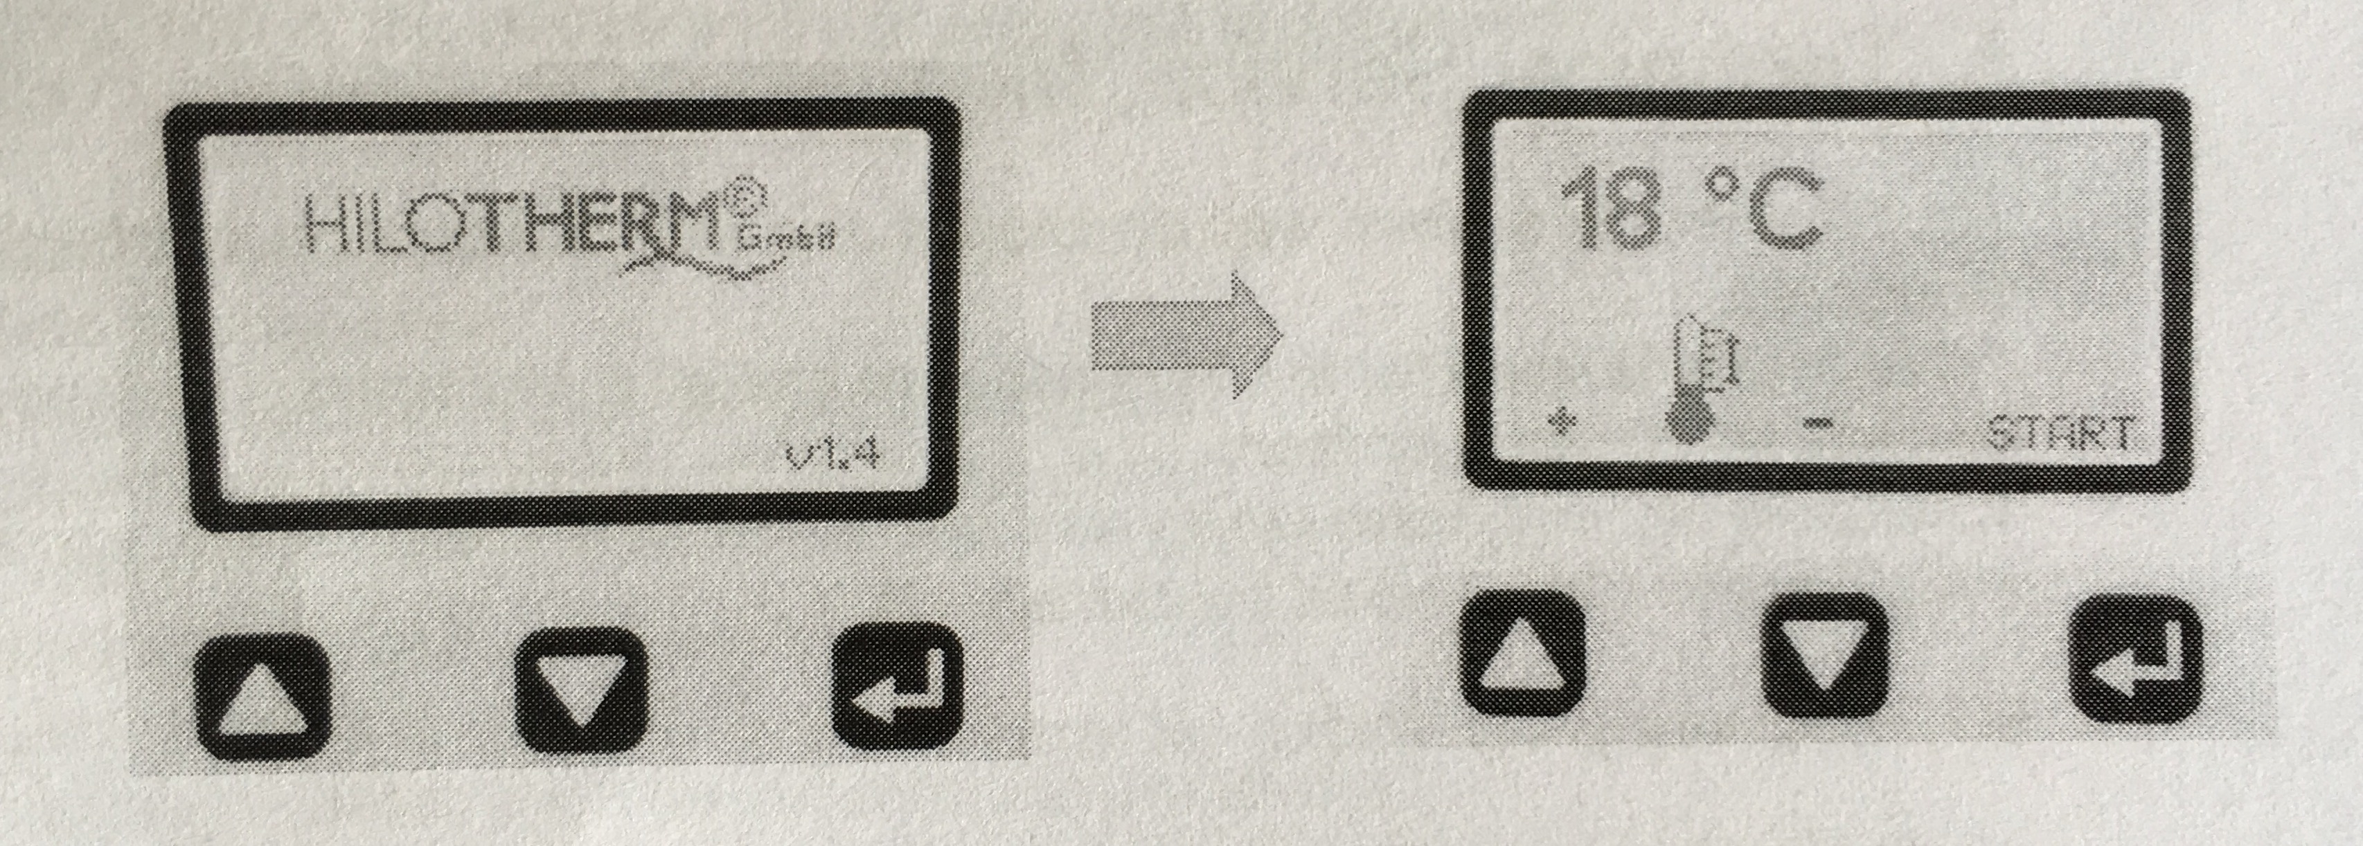
Device in operation
Device cools
Pressure pump running
The temperature can be changed in both operating states.

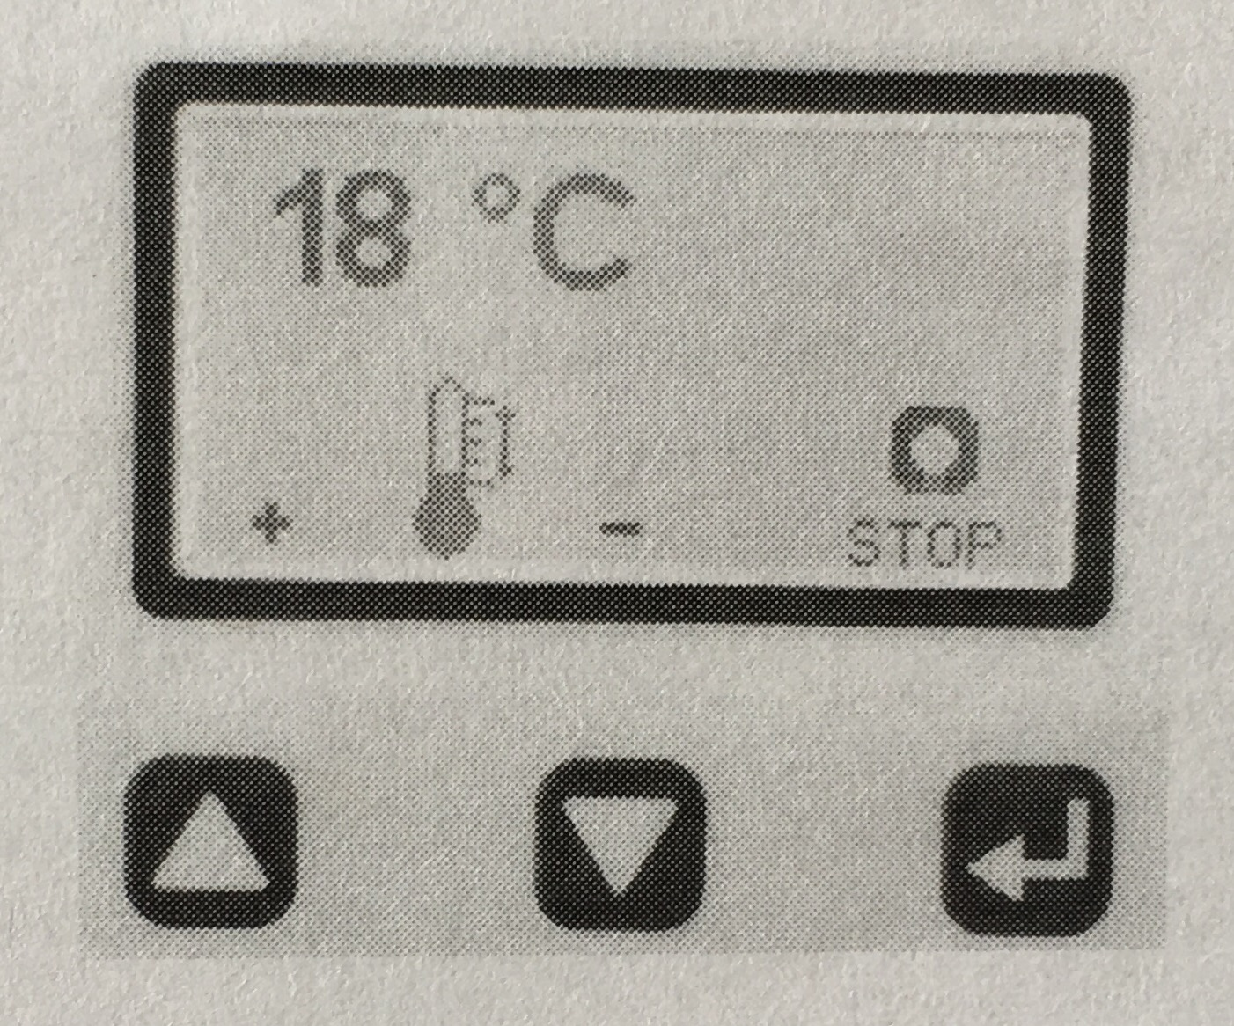
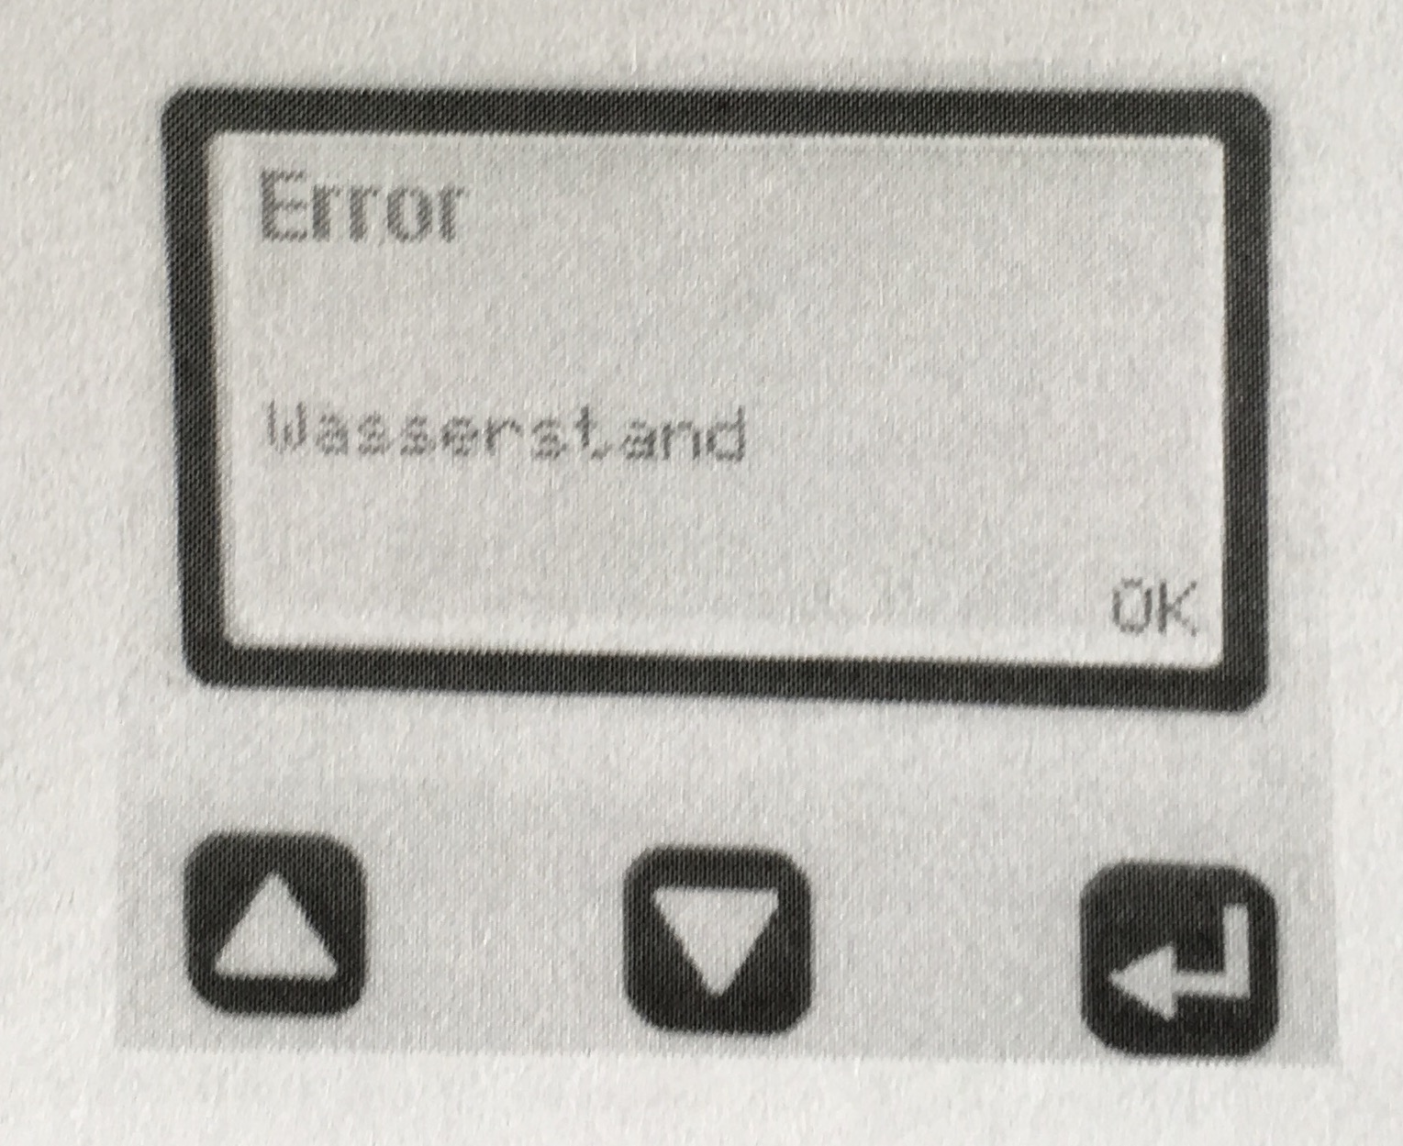
Trouble-Shooting
If a malfunction occurs, the word "Error" appears on the display; only the current malfunction is displayed. The display can be deleted with "Start" only after remedying the malfunction.

4. Cleaning and Disinfection
4.1 General
Attention! Make sure to disconnect the device from the mains before cleaning! Do not use sharp objects for cleaning.
4.2 Machine surface
Surfaces and parts of the device can be cleaned with standard household cleaning agents for cleaning plastic surfaces.
Make sure that no fluids enter the device, in particular through the venting slots on the machine sides.
4.3 Cuffs / Application parts: See chapter 9.7
6

